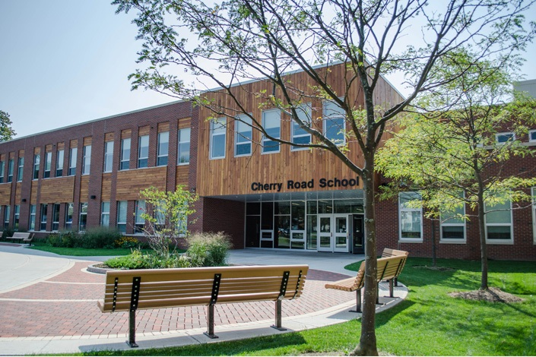

MINIMUM CAPACITY :-

The Minumum intake capacity

of students is between 850-1000

children

LIBRARY :-

The Libarary is Available.

CANTEEN:-

The Canteen Facility is Available.

BOARDING :-

No availablility of boarding.

SPORTS :-

There are different categories

sports available.

Girls Volleyball

Boys Volleyball

Football

|  |  |  |
| --- | --- | --- |
| WESTHILL CENTRAL SCHOOLS SYRACUSE - SCHOOL |  |  |
|  |  |  |
| School Detail :- Westhill Central Schools is a public school district immediately adjacent to the city of Syracuse, New York, USA, serving students primarily in the Town of Geddes and Town of Onondaga. The district is irregularly shaped with two large areas served joined by a narrow connection, as in the shape of an hourglass. The student body at the schools served by Westhill Central School District is 82.8% White, 5.5% Black, 1.8% Asian or Asian/Pacific Islander, 4.7% Hispanic/Latino, 0.3% American Indian or Alaska Native, and 0.2% Native Hawaiian or other Pacific Islander. In addition, 4.7% of students are two or more races, and 0% have not specified their race or ethnicity. |  |
|